**HIV and periodic presumptive treatment for female sex workers in Papua New Guinea**

Christopher Rock

Supervised by John Murray and Richard Gray

UNSW Australia

# Abstract

Periodic presumptive treatment (PPT) is an intervention which can quickly reduce prevalences of a curable sexually transmitted infection (STI). PPT could be used to lower the prevalence of certain STIs which increase the spread o f HIV. Some modelling has been done in this area, and found that decreases in HIV are possible using PPT in high-HIV settings, but little modelling has investigated whether this decrease is still possible in a country with an intermediate level of HIV and a declining rate of new infections. A deterministic compartmental model was built to model the effect of PPT on an STI, and the results were fed into an existing model for HIV in Papua New Guinea, to estimate the change in incidence of HIV. The sensitivity of the model to some assumptions was tested. Significant decreases in the level of the targeted STI can be achieved among the whole population, but much more so in urban settings. PPT provided to FSW across the whole country at high (>50%) coverages every two months can decrease national levels of the targeted STI moderately (>25%), but significantly in urban areas (>50%) over 10 years. This causes a decrease in HIV incidence of 4%-6%, but this effect increases to 6%-10% in urban areas.

# Introduction

Papua New Guinea (PNG) is a small developing island nation just north of Australia, with a population of 7.3 million people (website, 2015). PNG had its first reported case of HIV in 1987 ((WHO), 2005), and since then HIV has spread to infect 1 in 200 people in PNG, at which level it has plateaued. This is the highest HIV prevalence in the Pacific and five times the HIV prevalence in Australia (AIDSinfo, 2014). HIV is a virus, which eventually causes acquired immune deficiency syndrome (AIDS), a condition where a person has no T helper white blood cells. As at 2005, AIDS was the main cause of death at PNG’s main hospital in the capital Port Moresby. ((WHO), 2005). Reducing the number of people who acquire HIV is thus a priority for some policymakers.

There are certain sexually transmitted infections (STIs) which make a person more likely to transmit or acquire HIV. The two major STIs in PNG of which this is most true are herpes simplex virus 2, and syphilis. These STIs increase a person’s likelihood of acquiring or receiving HIV by 2 to 5 times (Patterson, et al., 2008), (Chen, et al., 2007), and (Zhang, et al., 2007), meaning these STIs are a  *cofactor* for HIV transmission. These STIs are very common in PNG. For example, syphilis occurs in one in 20 men, one in 12 women and 1 in 3 female sex workers (FSW) (Vallely, et al., 2010). By way of comparison, syphilis occurs in 1 in 14,000 people in Australia (Ooi, 2007), predominantly among men who have sex with men. Syphilis, like many STIs, is curable if treated early enough, but HSV-2, like HIV, can be suppressed with ongoing medication, but not cured. Thus, lowering levels of syphilis is of direct benefit to the population, but is also a possible method of lowering the incidence, or number of new cases, of HIV.

STIs apart from HIV also impose costs on PNG's health system. Syphilis is fatal in many cases, while chlamydia, an STI for which evidence of an HIV cofactor is weaker, leads to infertility. Approximately one third of syphilis infections (Branger, et al., 2009) and three quarters of chlamydia infections (Farley, et al., 2003) are asymptomatic, making them harder to treat. Moreover, for some STIs, such as chlamydia, there is no quick and cheap test that can be administered in the field. The only existing tests require laboratory equipment which is not available at all clinics in PNG.

In Australia, this delay in receiving results would not matter, since people would simply make another appointment and receive treatment shortly after they were notified of a positive diagnosis. In PNG this is less practical. Only 50% of the population has a mobile SIM (McNamara, 2014), and many people might be unwilling to receive notification about STI results using a shared phone. Large numbers of people diagnosed may not receive their diagnosis, or not receive it for a long time. Moreover, many people have to travel long distances to reach a clinic. According to (Gibson and Roselle), the average distance to a clinic is upwards of an hour in some areas, and such distances can have a significant impact on attendance (Müller, et al., 1998). Thus, people who have received a positive diagnosis, may also never return for treatment, or may only return later, after they have had a chance to infect others.

An alternative treatment program for chlamydia involves treating people immediately when they come into a clinic, without waiting for test results. This is called *periodic presumptive treatment* (PPT). PPT is typically provided to high-risk sub-populations, especially FSW ((WHO), 2005). PPT reduces prevalence both directly by treating people, and indirectly by reducing the pool of infected people transmitting the disease to uninfected people. PPT typically involves oral azithromycin plus sometimes an additional drug which targets certain STIs which might otherwise develop a resistance to azithromycin (Steen, et al., 2012). PPT has led to statistically significant reductions in chlamydia and gonorrhoea in several large-scale trials, but to variable outcomes for syphilis (Steen, et al., 2012). PPT can also be combined with screening for STIs for which cheap and portable screening apparatus exist, such as syphilis, to supplement the effects of the antibiotics. A PPT program would then become a combined intervention targeting some lower cofactor STIs being targeted for their own sake, some high-cofactor STIs, and HIV. This paper ignores the lower cofactor STIs, and focuses on the effect of the decrease in the high-cofactor STIs on HIV.

Several authors have discussed the use of PPT as an HIV reduction measure, but only one trial has measured HIV impact (Kaul, et al., 2004). This trial had insufficient power to determine whether PPT is effective for treating HIV (rate ratio 95% confidence interval 0.6-2.5). Thus, modelling is required to determine whether a meaningful effect is realistic. We found only one model which attempted this, used in (Vickerman, et al., 2010). This paper used a model to estimate the impact of treating chlamydia and gonorrhoea on HIV levels in an African context. (Vickerman, et al., 2010) found that an intervention which reached 10% of FSW could reduce HIV incidence by 10% in 3 years, which would be a very positive outcome. However, HIV is much more prevalent in Africa than in PNG (AIDSinfo, 2014), and (Vickerman, et al., 2010) only considered mature epidemics with HIV in a steady state. No modelling has been carried out in a setting with a less developed HIV infection, such as PNG. This paper aims to perform a pilot study for such a model.

# Methods

For this paper, we developed a dynamical deterministic compartmental homogenous mixing model for a curable STI with a high HIV cofactor. We calibrated the steady state of our model to the current prevalence of syphilis in PNG. Although there is enough data to model specific diseases differently, we assumed that there was only one STI with a significant HIV cofactor against which our intervention would be effective. We assumed that all other STIs with a non-trivial HIV cofactor had the same cofactor as the STI our intervention targeted, and that their prevalence would remain constant during our intervention. We calculated a combined prevalence by assuming the cofactor STIs were independent, and inputted them into an existing HIV model to forecast the impact of PPT on HIV. Our model structure is shown in Figure 1. Note that our model structure did not allow for any impact of HIV on our STI levels. HIV does have effects on the course of syphilis, but these effects are generally minor or rare (Zetola and Klausner, 2007).

Figure 1: Diagram showing the cascading structure of our model, where STI prevalences are calculated first, then used in calculating HIV incidence.  


Our HIV model was taken from (Gray, et al., 2011), as employed in (Vallely, et al., 2014). We modified some model parameters in line with updated information. As HIV clinics expanded into more areas of PNG, HIV prevalence estimates fell (AIDSinfo, 2014). UNAIDS, the UN peak body for HIV research, believes that as clinics have become accessible for more of the population, the data obtained from them is becoming a closer and closer representation of the true level of HIV, rather than reflecting an actual fall in HIV levels (UNAIDS, 2010). As such, we felt the HIV model had been calibrated to prevalence data that are too high. In addition, the model used an STI cofactor of 5, at the top of the confidence interval noted above. We reduced this to 2.4, which required the model to be recalibrated. To compensate, we adjusted the HIV transmission probabilities, the decrease in partnerships caused by knowing you have AIDS, the number of casual sex acts per partnership, and also the diagnosis rates.

The HIV model, both with its original parameters and with our updated parameters, suggested that HIV incidence was already falling. Our project investigated by how much this fall was accelerated under PPT. We thus measured the proportional fall in HIV incidence relative to the projected incidence of HIV if PPT was not introduced. Because our STI model was initially in steady state, the proportional decrease in curable STI prevalence was the same whether it was compared to the projected STI prevalence at that time or to the initial STI prevalence.

## Model for targeted STI

Our STI model used two non-interacting regions and four sub-populations. The HIV model divided PNG into rural and urban regions, so our STI model does the same. Baseline STI prevalences were all higher in the rural region than in the urban region, based on available data. Also following the HIV model, our STI model divides the population into female sex workers, general females, general males, and men who have sex with men and women (MSMW). Following our HIV model, we merge men who have sex exclusively with men into the MSMW category. In PNG, less than 10 reported cases of HIV per year are attributed to injecting drug use (Kelly, et al., 2012), so we do not model this population. We assumed that the STI targeted by PPT has baseline prevalences half of those assumed in the HIV model, and calculated the unaffected STI prevalences accordingly. Our baseline STI prevalences are shown in Table 1.

Table 1: Prevalences used as steady state for STI model

|  |  |  |
| --- | --- | --- |
| Population | Targeted STI prevalence (%) | Unaffected STI prevalence (%) |
| FSW | 16 | 19 |
| General females | 4.4 | 4.6 |
| General males | 3.4 | 3.5 |
| MSMW | 3.9 | 4.0 |

Our STI model was a SIPS model, where people could be susceptible, infected, or protected by PPT. We ignored any protection from any source other than PPT, so a person could only be in state $P$ if they had received PPT. Thus, when no PPT was being applied, the model collapsed to a SIS model.

We let $S_{X}$ and $I_{X}$ denote the proportions of population $X$ who were susceptible and infected, respectively, where $X$ becomes $S$ for FSW, $F$ for general females, $M$ for general males, or $B$ for MSMW. Since $S_{X}$ and $I_{X}$ were proportions, $S_{X}\left(t\right)+I_{X}\left(t\right)=1$ if $X$ were not receiving PPT. Then for each population $X$, susceptible people became infected at a rate $λ_{X}(t)$ dependent on the levels of infection in the populations which could infect people in $X$, and infected people stopped being infected at a constant rate $γ$. The infection rate $λ_{X}$ had the same form for FSW, general females and general males, and was slightly different for MSMW. Our model equations, using FSW as an example, are presented in Equation 1.

Equation 1: STI dynamics for FSW not receiving PPT

$$\dot{S_{S}}=γI_{S}-λ_{S}\left(t\right)S_{S}$$

$$\dot{I_{S}}={λ_{S}\left(t\right)S}_{S}-γI_{S}$$

$$λ_{S}\left(t\right)=β_{S}\left({\left(1-c_{1}\right)I}_{M}\left(t\right)+{c_{1}I}_{B}\left(t\right)\right)$$

$γ$ accounted for both existing treatment for the STI, and deaths and new entries into the sexually active population, since new entrants had a lower level of the targeted STI than people leaving the sexually active population. Less than 30% of mothers (Frank and Duke, 2000) receive ante-natal screening for syphilis, and only 15.5% of children born to mothers with syphilis show clinical evidence of syphilis and do not die in utero or neo-natally (Gomez, et al., 2013). This reduces the proportion of infected new entrants to the sexually active population below the proportion of infected mothers. If the targeted STI has serious symptoms, like syphilis, then the death rate among the infected may also be higher than among the uninfected. Thus, loss and replacement among the population both reduce the proportion of the population infected.

Susceptible FSW became infected at a variable rate $λ_{S}\left(t\right)$, which depended on the infection rate among males. $β_{S}$ is the maximum rate at which FSW would be infected if all of their partners were infected. We did not calculate our STI transmission probabilities from observed quantities, rather we fitted our transmission probabilities per period $β_{X}, X∈\{S,F,M,B\}$ to the desired steady state. The infection rate $λ_{S}\left(t\right)$ was simply this infection rate times the probability that a randomly selected partner of an FSW was infected. We assumed that general males and MSMW had the same levels of sexual partnerships with general females and FSW, so $c_{1}$ is just the proportion of males who are MSMW. Since we used a small time step when we implemented the model, the probability that two events happen to a person in one time step was negligible (10-6).

These equations were the same for general males and general females. For general females, we used the same infected-partner probability $\left({\left(1-c_{1}\right)I}_{M}\left(t\right)+{c_{1}I}_{B}\left(t\right)\right)$ that we used for FSW. For general males, we replace $I_{M}$ and $I_{B}$ with $I_{F}$ and $I_{S}$, and we replace $c_{1}$ with $c_{2}$, the probability that a random sex act by a general male will be with a FSW. $c_{2}$ must be adjusted for FSW performing more sex acts per person than general females perform.

For MSMW, we took a slightly different approach. We added the probability that an MSMW would acquire an STI from a female, which we assumed was the same as the probability that a general male would acquire an STI, to a separate probability that an MSMW will acquire an STI from an MSMW. Again, we ignored the probability of two infections happening in the same time step. Thus, $λ_{B}\left(t\right)$ took the form shown in Equation 2, below.

Equation 2: Infection rate equation for MSMW

$$λ_{B}\left(t\right)=β_{M}\left(\left(1-c_{2}\right)I_{F}+c_{2}I_{S}\right)+β_{B}I_{B}$$

We generalised from these equations when we added PPT. We assumed that under PPT, a fraction $ζ$ of FSW would be enrolled at random. If an FSW was enrolled, they would receive PPT at a rate $τ$ per month, whenever they were susceptible or infected. They would then immediately enter the protected state P, which they would leave at a constant rate $θ$, to become susceptible again. Otherwise, they would follow the same SIS dynamics as before. The dynamics are described in Equation 3, below.

Equation 3: STI dynamics for FSW receiving PPT

$$\dot{S_{S}}=γI_{S}-{(λ}_{S}\left(t\right)+τ)S_{S}$$

$$\dot{I_{S}}={λ_{S}\left(t\right)S}_{S}-(γ+τ)I_{S}$$

$$\dot{P_{S}}=τ\left(S_{S}+I_{S}\right)-\dot{θ}\dot{P_{S}}$$

In reality, people are likely to seek treatment more when they know they have just engaged in risky behaviour, or when it is a longer times since their last visit. Thus, the rate of PPT should be higher among infected people and lower among susceptible people. However, this effect is by nature very hard to prove experimentally, so we disregarded it. We also assumed that people's risk-taking behaviour such as condom use would not increase because they felt safer (known as *compensatory risk-taking*). This has not been observed in any PPT interventions to date, although it should remain a concern in implementing PPT (Steen, et al., 2012).

$τ$ is adjusted to allow for imperfect effectiveness of treatment. We reduce $τ$ by 5% to allow for clinician error administering treatment, and reduce it by a 1% per year to account for the STI developing antibiotic resistance.

We calculated the infection rate for males using the weighted average of the infection levels among FSW receiving treatment and FSW not receiving treatment.

# Results

shows that a very substantial impact on STI prevalences was projected among the FSW on PPT, even at moderate frequencies (treatment once every two months) and coverages (50%). The model also predicted significant decreases in STI prevalences in populations not receiving PPT. Population groups other than FSW, and FSW not on PPT, experienced falls in STI prevalence between 37% and 42% large as the fall experienced by FSW on PPT in one intervention, when 6 rounds of PPT per year were supplied to 75% coverage of FSW. Decreasing coverage to 50% reduced the impact on other populations to 26%-30% of the impact for FSW receiving PPT, and increasing frequency to 12 PPT rounds per year increased these impacts by 0.5%-0.7%. Overall levels of the targeted STI fell by >25%. Overall HIV incidence fell by >3.9%.

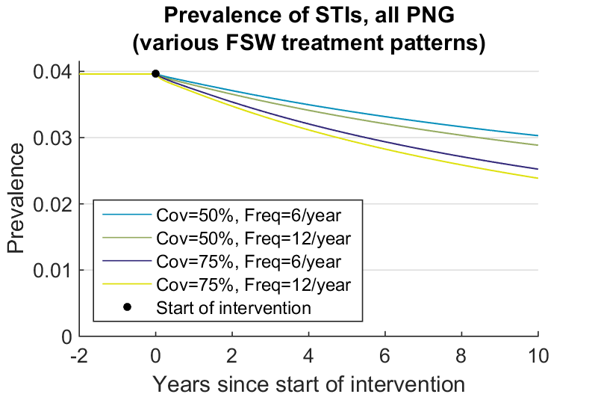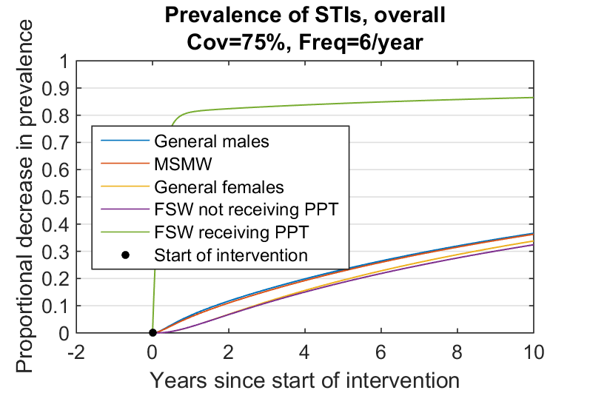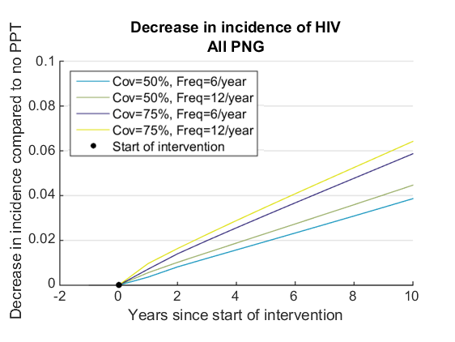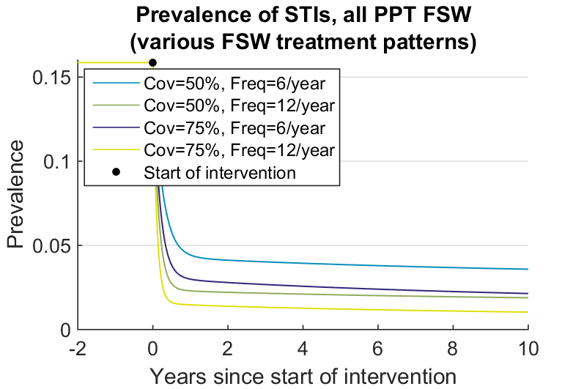Figure 2: Effect of PPT on targeted STI prevalences and HIV incidence. a. Effect on targeted STIs among FSW receiving PPT, b. Effect on STIs among all population groups, c. Effect of PPT on aggregate levels of targeted STI d. Effect of PPT on HIV incidence, as a percentage of each year’s projected HIV incidence. Cov = Coverage of FSW, Freq = frequency of PPT per year

c.

d.

b.

a.

shows that there was a much greater decrease in STI prevalence in urban areas than in rural areas. In rural areas, STI prevalences fell only slightly, which caused a smaller drop in HIV. In urban areas, STI prevalences fell by >50%. This caused a correspondingly greater fall HIV incidence, of >6%. Because PNG's population was largely rural, the lower impact of PPT in rural settings dominated the national impact results.

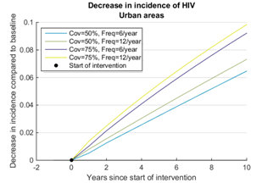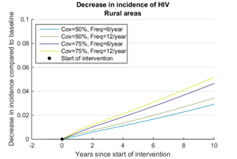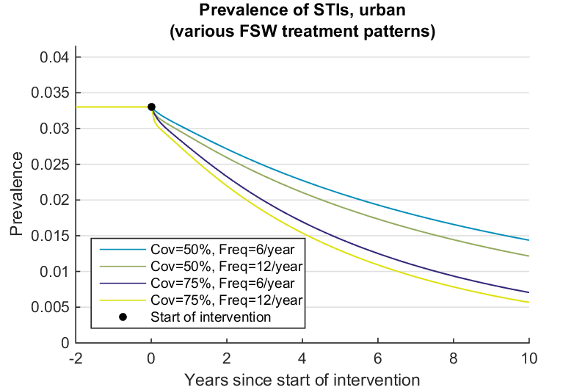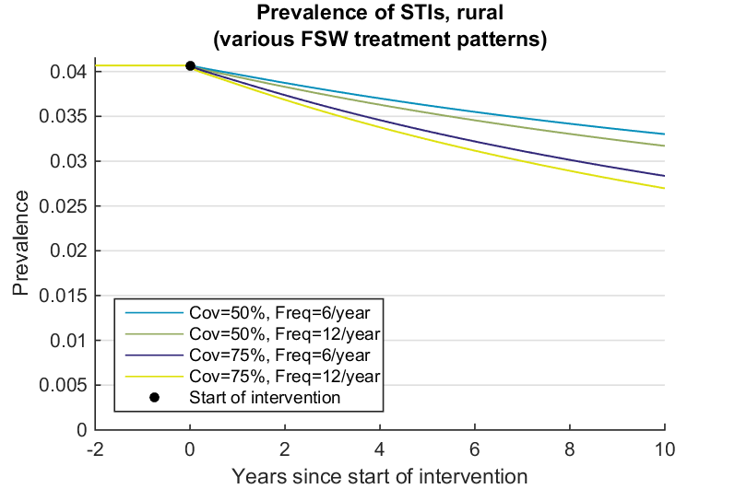Figure 3: Effect of PPT in different regions. a. Effect in rural areas on targeted STI, b. Effect in rural areas on HIV, c. Effect in urban areas on targeted STI, d. Effect in urban areas on HIV.

b.

a.

c.

d.

Running simulations to equilibrium, we found that increasing the coverage of treatment could eventually bring STI prevalence to zero in urban settings, but not in rural settings. In rural settings, FSW accounted for few enough STI infections initially that even when the FSW prevalence fell to 0, the general male and female populations reached new equilibrium STI prevalences away from 0.

b.

Increasing the frequency of treatment increases the impact of PPT on STI prevalence and HIV incidence until around 2 doses per month, where the change in impact becomes smaller. In urban settings, increasing coverage keeps accelerating STI prevalences in falling to zero until around 80% coverage, at which point FSW start transmitting a negligible proportion of infections. Away from these two bounds, the benefit from increasing coverage was much larger than the benefit from increasing frequency, per unit of treatment.

## Sensitivity analysis

Decreasing the proportion of cofactor STIs which were the targeted STI by 10% caused a 1.3%-2% larger projected decrease in the curable STI’s prevalence, but it reduced the proportion of STIs that were curable. Overall, it caused the model to project a 9%-10% smaller decrease in HIV incidence. Conversely, increasing the proportion of cofactor STIs which were the targeted STI caused a 1.3%-2% smaller projected decrease in the curable STI’s prevalence, and a 9%-10% larger projected impact on HIV.

Increasing the total level of STIs by 10%, in the same proportion, led to the same fall in the curable STI’s prevalence that was caused by changing the proportion of STIs that were the targeted STI. However, increasing the total level of STIs also increased the number of HIV infections caused by STIs in the baseline case. Thus, when we increased the total level of STIs, PPT caused decrease in HIV incidence that was proportionally larger by 5.5%-6%. Decreasing the total level of STIs by 10% led to a 4.5%-5% larger decrease in HIV incidence.

Our model kept rural and urban areas separate, so providing PPT only in urban areas led to the same decrease in STIs in urban areas as providing PPT everywhere, and meant STIs remained constant in rural areas. This caused a reduction in HIV in urban areas that was only 2% smaller than the reduction caused by the nationwide intervention.

Decreasing the duration of infections with the targeted STI by 10%, and re-calibrating the infection rates to keep baseline STI levels unaffected, caused the impact on STI levels to fall by 4%-5%. This decreased the effect on HIV by 3%-3.5%. Increasing the duration by 10% caused the impact on STI levels and HIV incidence to rise by 4%-5% and 2.5%-3% respectively.

Decreasing the STI cofactor by 10% had no effect on STIs, as expected, but reduced the projected impact on HIV incidence of PPT by 15% in all interventions. Increasing the cofactor by 10% increased the projected impact on HIV incidence by 13%.

No other parameters had an impact on STI prevalences or HIV incidence of more than 3% when increased or decreased by 10%. Figure 4 shows the effect of the changes described above under different interventions. Supplementary Figure 1 shows the sensitivities to other parameters.

Figure 4: Effect on impact size of univariate changes in parameters, for parameters with large effects. a. Targeted STI prevalences, b. on HIV incidence 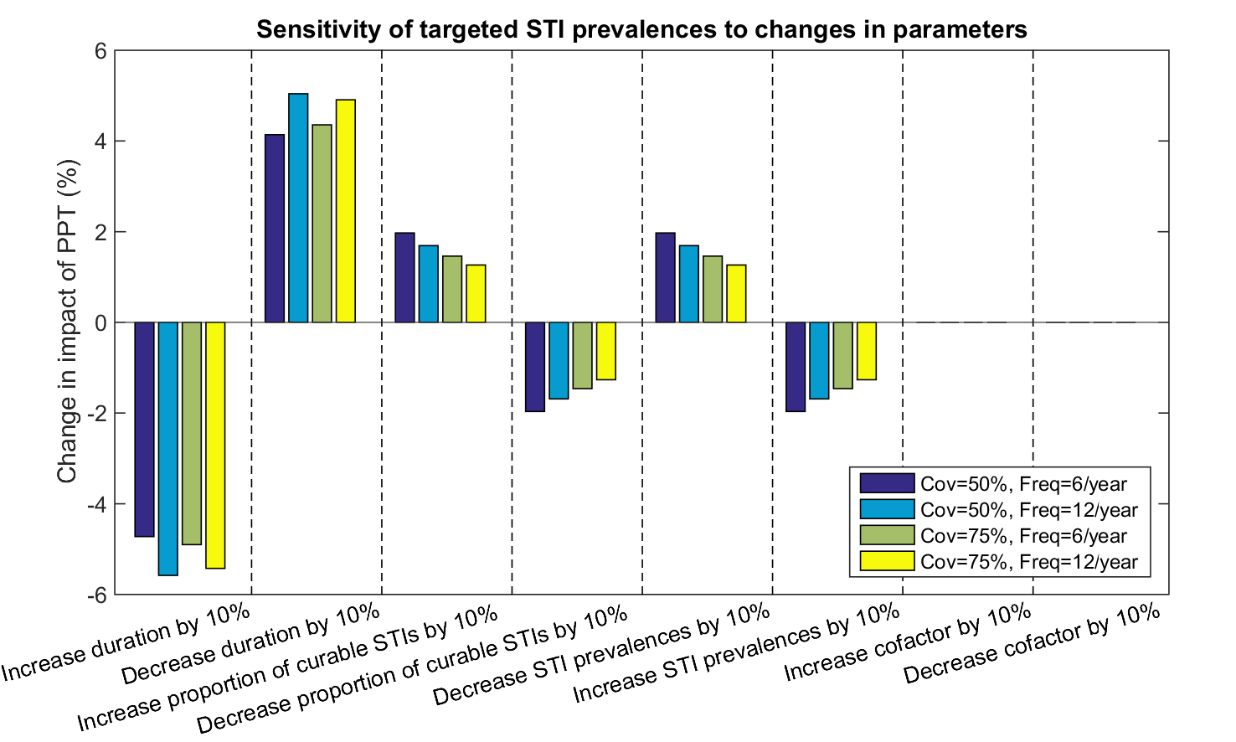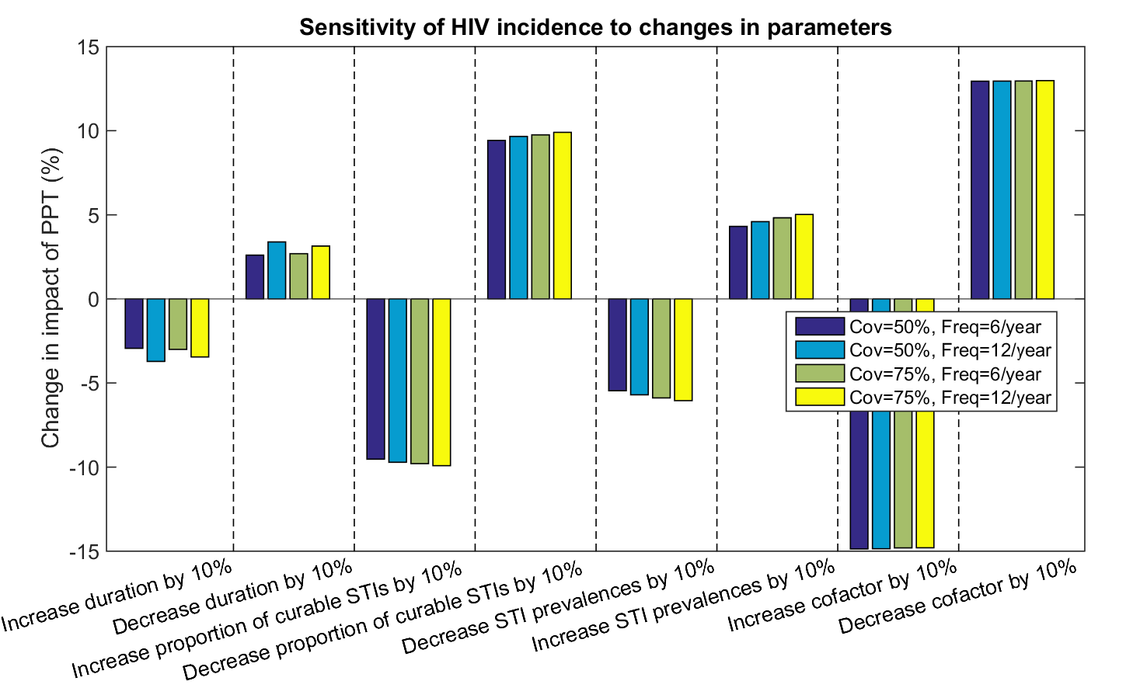

a.

b.

# Discussion

Our model projected that HIV incidence could be reduced by 4%-6% nationally by providing PPT to 50%-75% of FSW once every one or two months. HIV could be reduced in urban areas by 6%-10% applying this level of treatment. Among people not receiving treatment, our model projected falls in STI levels between a quarter and two fifths the size of the fall in STI levels among people receiving treatment.

Our analysis had several limitations. Fundamentally, our paper was based on a model, and as such was only as good as our data values and assumptions. It is in the nature of all assumptions and models to be wrong. We can expect a sufficiently full model to represent reality closely enough to provide general insights into reality, but effects outside the model are always able to devalue our insights.

There were several specific limitations to our model. We did not include any information about the disease progression of the STI we modelled. Nor did we include the effect on STI levels of migration between areas. We also have assumed homogenous behaviour. This probably made our results overly optimistic since there may be highly sexually active sub-communities of males, females and FSW which maintain higher STI prevalences, producing the same reduction in PPT effectiveness against the STI that was observed when we increased the overall STI prevalence. If it were possible to target the people at the highest risk, this would allow a more effective intervention. However, it is also possible that the people at most risk would be the hardest to reach.

We assumed no difference in disease duration between genders, or between urban and rural settings. We assumed that STI cofactors are not additive. We have also not accounted for congenital syphilis in a manner which allows us to consider the effects of prevention of mother-to-child transmission.

We have not considered the consequences of ending our program. (Pourbohloul, et al., 2003) suggests that a quick rebound in syphilis levels can occur when a presumptive treatment program ends. However, most PPT programs are integrated with condom and safe sex promotion, partner education programs or other HIV reduction programs, and these are often able to keep STI levels down (Steen, et al., 2012). We have not considered the effects of such a program.

Our model structure prevented us testing the effect that any impact of HIV on STI progression might have on our results. In a recent meta-analysis, (Zetola and Klausner, 2007) found that “Despite minor differences, syphilis presents similarly in HIV-infected and HIV-uninfected patients.” However, some differences, such as symptoms of primary and secondary syphilis overlapping (Zetola and Klausner, 2007), could affect syphilis epidemiology. We have also not modelled for any long-term resistance to the STI, such as is possible for some STIs including chlamydia (Batteiger, et al., 2010). Some people develop a partial immunity to chlamydia if it is left untreated, and PPT could interfere with this immunity developing. Our model would need to be modified before it could be adapted to chlamydia.

We have accounted for antibiotic resistance in the targeted STI in a very simplified manner. Syphilis can easily develop resistance to the most common antibiotic provided for PPT, azithromycin (Mitchell, et al., 2006). Modelling could estimate the risk that PPT would cause such resistance to spread.

Our paper does not make any cost-benefit analysis of PPT. Any such work must take care to account for all costs and benefits of PPT, such as the economic costs of people’s time spent visiting a clinic, compensatory risk-taking, or increasing a social stigma that FSW are all diseased, which is very damaging to sex worker empowerment (Jenkins, 2000). FSW empowerment in turn contributes to safer sex practices, in addition to economic benefits (Jenkins, 2000).

We found that increasing the coverage of PPT was more important than increasing the frequency with which it is administered. While there is a slightly higher prevalence of STIs among FSWs receiving PPT if PPT is administered to 50% of FSWs every month than if it is administered to 75% of FSWs every two months, the increase in the number of people treated outweighs the difference in prevalence. Also, the impact on other populations is maximised by increasing coverage rather than frequency of treatment. This is consistent with (Vickerman, et al., 2010)'s results, although their paper does not emphasise the fact.

Our results may be optimistic because of our homogenous mixing and behaviour assumptions and neglect of migration and lack of detail around STI progression. Despite this, our results still suggest that providing PPT to FSW in PNG could be a plausible combined intervention for STIs and HIV in settings with a high proportion of FSW, if PPT can reach a high (>50%) proportion of them. A reduction in HIV incidence is likely to be seen at the population level. Tis reduction will deepen over a number of years, compared to current projections. An intervention could involve a combination of PPT and screening for STIs for which this is possible, and should involve other HIV control measures.

(WHO), W.H.O. (2005) Summary Country Profile for HIV/AIDS treatment scale-up.

AIDSinfo (2014) hiv_prevalence_ages_15_49.xls.

Batteiger, B.E.*, et al.* (2010) Protective Immunity to Chlamydia trachomatis Genital Infection: Evidence from Human Studies, *Journal of Infectious Diseases*, **201**, S178-S189.

Branger, J.*, et al.* (2009) High Incidence of Asymptomatic Syphilis in HIV-Infected MSM Justifies Routine Screening, *Sexually Transmitted Diseases*, **36**, 84-85.

Chen, X.S.*, et al.* (2007) Detection of Acute and Established HIV Infections in Sexually Transmitted Disease Clinics in Guangxi, China: Implications for Screening and Prevention of HIV Infection, *J Infect Dis*, **196**, 1654-1661.

Farley, T.A., Cohen, D.A. and Elkins, W. (2003) Asymptomatic sexually transmitted diseases: the case for screening, *Prev Med*, **36**, 502-509.

Frank, D. and Duke, T. (2000) Congenital syphilis at Goroka Base Hospital: incidence, clinical features and risk factors for mortality (abstract only), *P N G Med J*, **43**, 121-126.

Gibson and Roselle Poverty and Access to Roads in Papua New Guinea *.

Gomez, G.B.*, et al.* (2013) Untreated maternal syphilis and adverse outcomes of pregnancy: a systematic review and meta-analysis, *Bulletin of the World Health Organization* **91**, 217-226.

Gray, R.*, et al.* (2011) The PNG HIV Model-Summary and Results: Explaining the past, describing the present, and forecasting the future of the HIV epidemic in PNG, *The Kirby Institute*.

Jenkins, C. (2000) Female sex worker HIV prevention projects : lessons learnt from Papua New Guinea, India and Bangladesh, *UNAIDS Case Study, UNAIDS Best Practice Collection*.

Kaul, R.*, et al.* (2004) Monthly antibiotic chemoprophylaxis and incidence of sexually transmitted infections and hiv-1 infection in kenyan sex workers: A randomized controlled trial, *JAMA*, **291**, 2555-2562.

Kelly, A.*, et al.* (2012) Emerging HIV Risks in Papua New Guinea.

McNamara, S. (2014) Papua New Guinea - Telecoms, Mobile and Broadband - Market Insights and Statistics.

Mitchell, S.J.*, et al.* (2006) Azithromycin-resistant syphilis infection: San Francisco, California, 2000-2004, *Clin Infect Dis*, **42**, 337-345.

Müller, I.*, et al.* (1998) The effect of distance from home on attendance at a small rural health centre in Papua New Guinea, *International Journal of Epidemiology*, **27**, 878-884.

Ooi, C. (2007) Testing for sexually transmitted infections, *Aust Prescr*, **30**, 8-13.

Patterson, T.L.*, et al.* (2008) Prevalence and Correlates of HIV Infection among Female Sex Workers in Two Mexico-U.S. Border Cities, *J Infect Dis*, **197**, 728-732.

Pourbohloul, B., Rekart, M.L. and Brunham, R.C. (2003) Impact of Mass Treatment on Syphilis Transmission: A Mathematical Modeling Approach, *Sexually Transmitted Diseases*, **30**, 297-305.

Steen, R.*, et al.* (2012) Periodic presumptive treatment of curable sexually transmitted infections among sex workers: a systematic review, *Aids*, **26**, 437-445.

Steen, R.*, et al.* (2012) Periodic presumptive treatment of curable sexually transmitted infections among sex workers: a systematic review, *Aids*, **26**, 437-445.

UNAIDS (2010) Papua New Guinea releases new HIV prevalence estimates.

Vallely, A.*, et al.* (2010) The prevalence of sexually transmitted infections in Papua New Guinea: a systematic review and meta-analysis, *PLoS One*, **5**, e15586.

Vallely, A.*, et al.* (2014) High prevalence and incidence of HIV, sexually transmissible infections and penile foreskin cutting among sexual health clinic attendees in Papua New Guinea, *Sex Health*, **11**, 58-66.

Vickerman, P.*, et al.* (2010) Using mathematical modelling to estimate the impact of periodic presumptive treatment on the transmission of sexually transmitted infections and HIV among female sex workers, *Sexually Transmitted Infections*, **86**, 163-168.

website, D.o.F.A.a.T. (2015) Papua New Guinea country brief.

Zetola, N.M. and Klausner, J.D. (2007) Syphilis and HIV Infection: An Update, *Clinical Infectious Diseases*, **44**, 1222-1228.

Zhang, X.*, et al.* (2007) Risk factors of HIV infection and prevalence of co-infections among men who have sex with men in Beijing, China, *Aids*, **21**.

All computations were performed using the MATLAB© 8.4 language (The MathWorks, Inc., 2014). Code used in this project is available at [github.com/Christopher-Rock/hivandppt](https://github.com/Christopher-Rock/hivandppt).

# Supplementary Figure

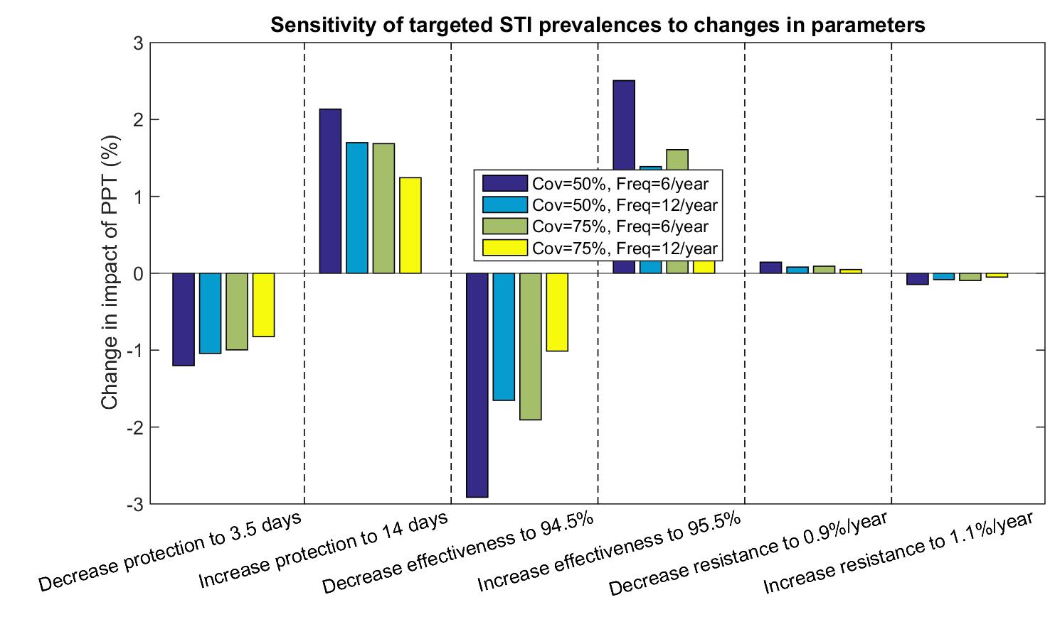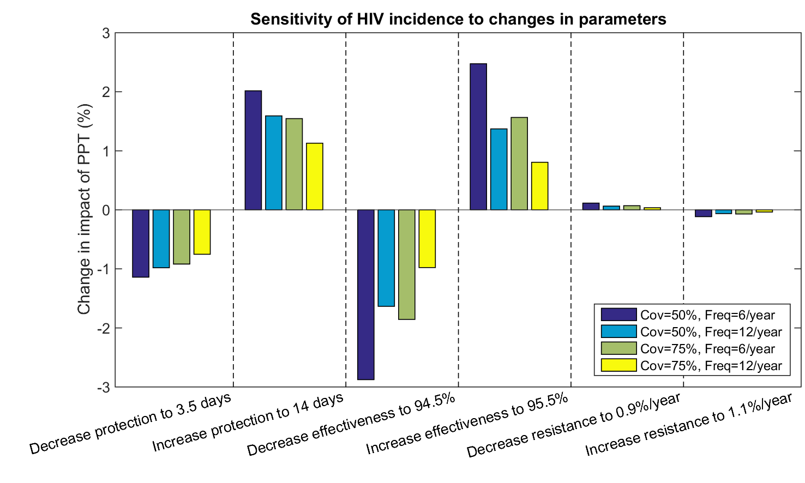Supplementary Figure : Sensitivity of results to parameter changes, for parameters with smaller effects. a. Sensitivity of change in targeted STI prevalence, b. Sensitivity of change in HIV incidence, c. Sensitivity of change in HIV incidence in urban areas

a.

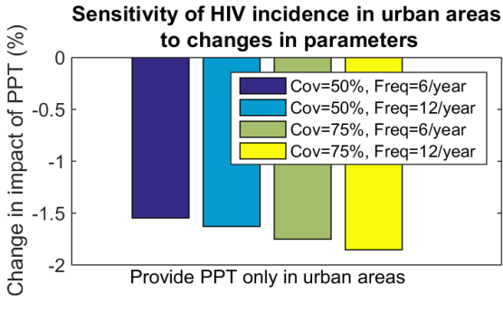

c.

b.